

**FIT5057 Project Management**

**Assignment Three – Team Assignment Individual Submission**

**Cipher Protocol Shadow Nexus - Cyberpunk Action Stealth Game Project Management Execution**

MONTH October 29, 2024

Student ID and Full Name:33429472 Ziqi Pei

Team number:603

Applied class:Applied Friday 5-7pm

# 

# **Contents**

DELIVERABLE 1: Agile Project Foundations ..................................................................3

Task 1.1 Project Vision and Initial Requirements...............................................................3

Task 1.2: Scrum Persona Development.............................................................................10

Task 1.3 Journey Mapping.................................................................................................13

DELIVERABLE 2: Agile Planning and Sprint Allocation ..............................................15

Task 2.1 Product Backlog..................................................................................................15

Task 2.2 Strategic Sprint Allocation..................................................................................19

Task 2.3 Sprint 1 Execution Plan......................................................................................21

DELIVERABLE 3: Agile Reflection and Professional Development..............................28

Task 3.1: Reflection on Agile Game..................................................................................29

Task 3.2: Personal Reflection and Career Development in Agile Roles ..........................31

Team Presentation and Agile Artefacts.............................................................................35

References.........................................................................................................................36

Generative AI - Acknowledgement of Use.......................................................................36

**Deliverable 1. Agile Project Foundations**

**Task 1.1: Project Vision and Initial Requirements**

|  |  |
| --- | --- |
| Problem | 1. Report Purpose and Discussion:  The cyberpunk game market currently lacks deeply immersive experiences where players can genuinely shape their environment and influence the storyline. Most games in the genre are static, providing limited replayability and predictable interactions, which fails to satisfy players seeking a personalized and evolving narrative. Cipher Protocol: Shadow Nexus addresses this gap by offering an interactive game world that adapts to players' choices in real-time, providing a unique and emotionally impactful experience with each playthrough. The game is designed for players who crave strategic depth, adaptive environments, and complex moral choices, ultimately delivering an innovative and unmatched gameplay experience that empowers players to forge their own path.  2. Project Terms of Reference:  2.1 The Client’s case story summary  NexaForge Studios wants to utilize cutting-edge technology to deliver a compelling cyberpunk action stealth game with procedurally generated environments. The game needs to support real-time AI that reacts to player actions, dynamic level designs, and a system for player-driven narrative branching.  2.2. PM methodology:  The Agile methodology is an iterative, customer-focused project management strategy that enables rapid delivery and adaptation to change. Using Agile, the development team can adjust gameplay features, ensuring that player feedback and evolving gameplay mechanics are considered during every iteration. This approach facilitates continuous improvements and adaptive solutions, aligned with both short-term sprint goals and long-term project vision.  Agile project management offers flexibility, making it particularly suitable for complex game development processes like Cipher Protocol: Shadow Nexus. |
| Objective | Cipher Protocol: Shadow Nexus aims to revolutionize the cyberpunk action-stealth gaming genre by placing players at the heart of a dynamic, evolving game world. The project strives to create an immersive experience where every decision the player makes influences the game environment, storyline, and character progression. With procedural level generation, adaptive AI systems, and a sophisticated moral choice mechanism, our vision is to offer players an emotionally compelling and personalized gameplay journey that continuously adapts to their actions and decisions in real-time. The scope of this project includes creating a cross-platform game that engages players through a blend of stealth, action, and narrative-driven gameplay, while also offering post-launch content to maintain long-term player interest and community growth. Cipher Protocol: Shadow Nexus aligns with NexaForge Studios' strategic goals by fostering innovation, expanding market presence, and engaging a diverse, global player community.  Aligned with **NexaForge Studios'** strategic goals, **Cipher Protocol: Shadow Nexus** will not only enrich player experiences but also drive industry innovation by delivering cross-platform functionality and secure data management. Long-term player engagement is further enhanced through the incorporation of post-launch downloadable content (DLC). This project ultimately aims to attract a broad audience, foster a loyal player community, and provide stakeholders—players, developers, and the studio itself—with enhanced creativity, engagement, and a significant competitive edge.  The stakeholder management process will involve stakeholder analysis and engagement strategies, employing **Power/Influence and Interest grids** to assess their involvement. Ensuring timely communication with key stakeholders like project sponsors and team leads will be vital for achieving project success  Develop a personalized, engaging gameplay experience using dynamic level design, adaptive AI, and a moral choice system that provides multiple paths and impactful decisions, enhancing replayability and player retention (Jones & Taylor, 2022).  Untitled diagram-2024-10-27-024411 |
| Impact | Cipher Protocol: Shadow Nexus stands out by delivering a deeply personalized, narrative-driven experience that adapts to each player's decisions. By blending procedural level design, adaptive AI, and a moral choice system, the game offers significant benefits, including enhanced replayability, strategic depth, and emotional engagement. Players will feel a heightened sense of agency, making each playthrough unique and tailored to their choices. NexaForge Studios aims to push the boundaries of interactive storytelling, thereby establishing new industry standards and fostering a strong player community through ongoing content updates and multiplayer support.  **Players**: They gain a more engaging, narrative-driven experience that adapts to their decisions, offering unique playthroughs and emotionally compelling narratives. This dynamic approach enhances the sense of agency and deepens immersion.  **Developers**: By working with advanced game mechanics such as procedural level generation and adaptive AI, developers are encouraged to expand their creative and technical skills. The project fosters an environment where innovation is integral, enhancing overall development expertise.  **NexaForge Studios**: The studio benefits from increased brand recognition and differentiation in a competitive market. **Cipher Protocol** is positioned to create a loyal community through long-term engagement with post-launch downloadable content (DLC), ultimately driving profitability and establishing **NexaForge** as a leader in the cyberpunk action-stealth genre.  The governance framework is key to achieving these impacts, providing structured oversight to ensure alignment with **NexaForge's** vision and delivering a high-quality product that meets stakeholder expectations(Wright & Campbell, 2023).. Oversight bodies—including the Steering Committee, Project Board, Change Control Board, Quality Assurance Team, and Risk Management Committee—collaborate to ensure strategic alignment, high-quality development, effective change management, and proactive risk mitigation.  Untitled diagram-2024-10-27-021647 |

|  |  |
| --- | --- |
| Goals | Benefit |
| 1. Provides an engaging storyline with diverse levels that change based on player choices. | For players who enjoy strategic gameplay, this offers unique challenges and a personalized experience with each playthrough, increasing engagement and replayability (Smith, 2021). |
| 2. Adaptive AI dynamically responds to player actions, offering unique and evolving challenges. | For players seeking a challenging experience, this feature keeps gameplay fresh and unpredictable, making each session unique (Jones & Taylor, 2022). |
| 3. Dynamic level generation based on player progress and choices ensures no two playthroughs are identical. | For players who value creativity and variability, this feature provides endless replayability and maintains engagement over time (Wright & Campbell, 2023). |
| 4. Players' decisions directly impact the game’s world and storyline, leading to multiple possible outcomes. | Story-driven players experience personalized, impactful narratives, increasing their emotional investment and desire to replay the game (Smith, 2021). |
| 5. Incorporates adaptive stealth mechanics and intelligent enemy behaviors, allowing for strategic decision-making. | For players who prefer tactical and stealth-based gameplay, this feature provides an added layer of depth and challenge, enhancing the overall experience (Jones & Taylor, 2022). |
| 6. Includes post-launch downloadable content (DLC) that introduces additional missions, characters, and storylines. | For long-term players, this ensures ongoing engagement and community growth by offering fresh content and extending the game's lifecycle (Wright & Campbell, 2023). |
| 7. Provides intuitive, visually appealing, and cross-platform user interface (UI) consistency. | For players switching between devices, this ensures a seamless and satisfying experience across multiple platforms (Smith, 2021). |
| 8. Robust development environment ensures stable workflows, including automated testing and Docker containerization. | For the development team, this reduces errors and downtime, allowing them to focus on delivering high-quality features efficiently (Jones & Taylor, 2022). |
| 9. Provides scalable multiplayer support and server stability for high-concurrency environments. | For social and competitive players, this ensures smooth, lag-free multiplayer gameplay, enhancing the game's community-driven experience (Wright & Campbell, 2023). |
| 10. Offers secure cloud save functionality to ensure safe, continuous access to player data across devices. | For players, this provides peace of mind that their progress is safe, allowing them to continue playing on multiple platforms without worry (Smith, 2021). |
| 11. Implements advanced encryption for player data, ensuring privacy and security in all game interactions. | For privacy-conscious players, this provides confidence that their personal data is protected (Jones & Taylor, 2022). |
| 12. Regular community events, challenges, and in-game competitions to foster a vibrant player community. | This creates a strong, loyal player base, promoting engagement and supporting long-term game success (Wright & Campbell, 2023). |
| 13. Seamless stealth and combat integration allows players to fluidly switch between tactics based on playstyle. | For players who enjoy flexibility in their approach, this provides a dynamic and responsive gameplay experience (Smith, 2021). |
| 14. Real-time feedback system for collecting and analyzing player input during gameplay. | For the development team, this ensures any gameplay issues or user experience problems are quickly identified and addressed, improving game quality (Jones & Taylor, 2022). |
| 15. Automated testing ensures that each new feature is tested without disrupting existing functionality. | For developers and testers, this reduces the risk of introducing bugs and ensures stable releases (Wright & Campbell, 2023). |
| 16. Comprehensive testing ensures the game runs smoothly across multiple platforms, enhancing accessibility and user retention. | For cross-platform players, this ensures a consistent, high-performance experience regardless of device (Smith, 2021). |
| 17. A strong marketing strategy, including pre-launch promotions and partnerships with influencers. | For the marketing team, this ensures maximum visibility and hype leading up to the game's release, helping secure a strong player base (Jones & Taylor, 2022). |
| 18. Post-launch support includes ongoing updates and downloadable content (DLC) to maintain engagement. | For long-term players, this ensures ongoing engagement and a steady stream of new content, fostering community growth (Wright & Campbell, 2023). |
| 19. Multiplayer and cooperative modes with scalable cloud infrastructure ensure smooth, real-time gameplay. | For multiplayer gamers, this supports high-volume interactions with minimal latency, ensuring smooth and engaging gameplay (Smith, 2021). |
| 20. High-performance optimization ensures a minimum of 60 FPS with quick load times across platforms like PC, PS5, and Xbox | This ensures a smooth and seamless experience for performance-focused players who expect technical excellence (Jones & Taylor, 2022). |

**Task 1.2: Scrum Persona Development**

### Persona 1: Alex Matthen

#### Description:

Alex is a 28-year-old software engineer with a passion for narrative-driven, challenging games. With a strong background in coding, he appreciates games that offer complex gameplay mechanics and strategic depth. His interest lies in games featuring hacking and AI-driven systems, as they allow him to leverage his technical skills and think critically.

#### Goals/Needs:

(1)To find a game that challenges his strategic thinking and keeps him engaged with complex mechanics.

(2)Seeks games that adapt to his playstyle, providing new challenges each time he plays.

(3)Values replayability and games that reward creative problem-solving.

#### Frustrations/Pain Points:

(1)Frustrated with games that become repetitive or fail to challenge his skills.

(2)Dislikes shallow AI that doesn’t adapt to player choices, reducing the game’s depth.

(3)Finds it demotivating when games lack the flexibility for players to explore alternative playstyles.

#### Reflection:

Alex would benefit greatly from the adaptive AI in Cipher Protocol. The dynamic AI adapts to his actions, keeping missions fresh and challenging. This system allows Alex to continuously strategize, engage deeply with the game, and experiment with different approaches, catering to his desire for meaningful, replayable gameplay experiences.

### Persona 2: Emily Chen

### Description:

### Emily is a 32-year-old content writer and avid gamer who values games that offer immersive worlds and meaningful storytelling. She loves RPGs and spends her free time writing about games on her blog. She seeks emotional engagement and meaningful player choices, allowing her to shape the story’s progression.

### Goals/Needs:

### (1)Wants a game that prioritizes narrative depth, with choices that impact the storyline.

### (2)Looks for games where she feels connected to the characters and world.

### (3)Seeks a unique experience in each playthrough, where her decisions make a noticeable difference.

### Frustrations/Pain Points:

### (1)Dislikes games with superficial decision-making systems that don’t significantly alter the story.

### (2)Feels disappointed when narrative paths are predictable or lack meaningful consequences.

### (3)Struggles to stay engaged if the game’s story doesn’t allow for diverse choices that influence the game world.

### Reflection:

### The Cipher Protocol moral choice system resonates with Emily’s gaming needs, as it offers her a chance to make impactful decisions that genuinely shape the story. This feature would allow Emily to feel a deeper connection to the game’s characters and narrative, aligning with her desire for meaningful engagement.

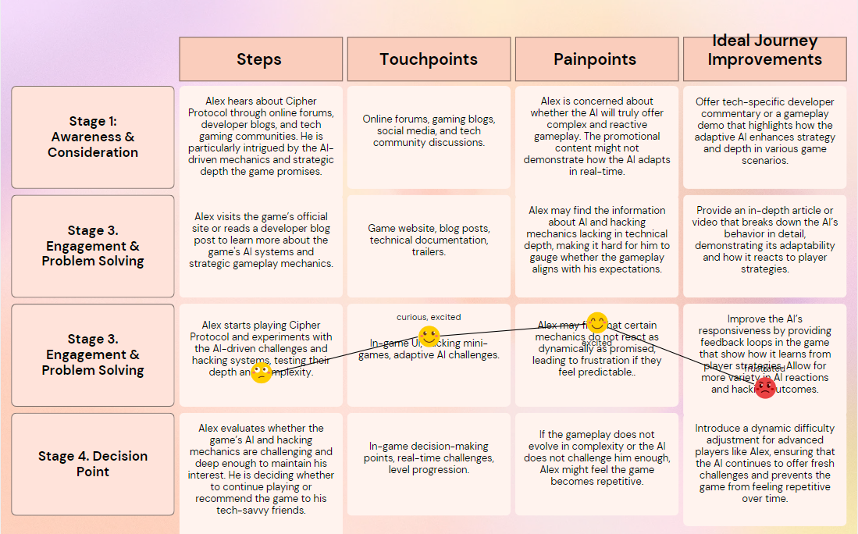**Task 1.3 Journey Mapping**

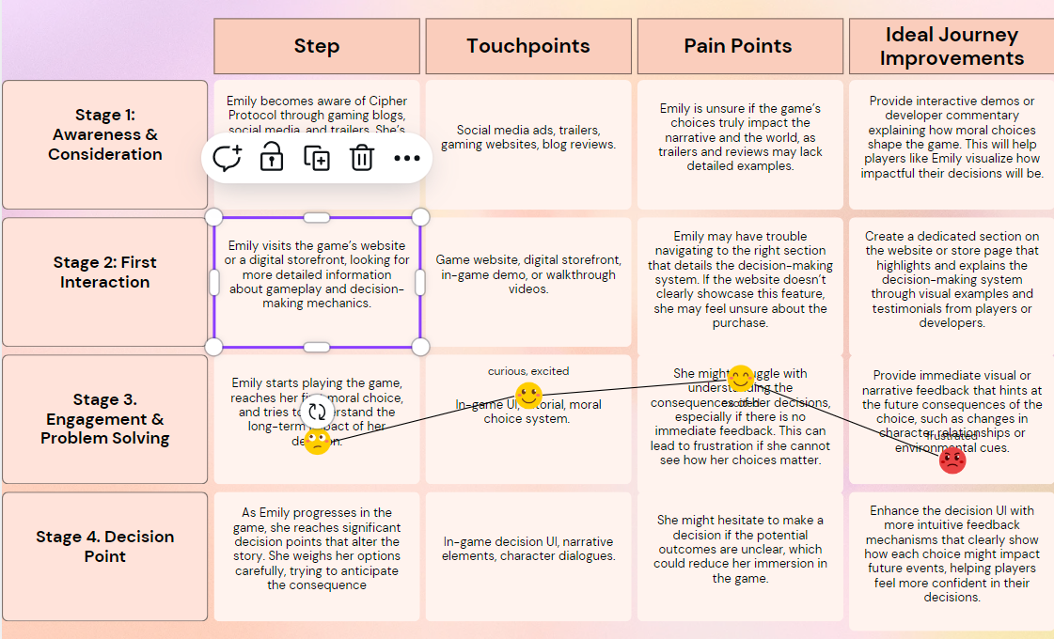

**Deliverable 2. Agile Planning and Sprint Allocation**

**Task 2.1: Develop a Comprehensive Product Backlog**

|  |  |  |  |  |
| --- | --- | --- | --- | --- |
| **Epic** | **Feature** | **User Story** | **Priority (MoSCoW etc.)** | **Estimated effort (Story Points)** |
| Dynamic Level Design | Procedural Level Generation | As a player, I want levels to adapt based on my actions and choices, so that each playthrough feels unique and challenging (Anderson, 2019). | Must Have | 5 |
| Adaptive AI System | Real-Time AI Response | As a player, I want the enemies to react to my tactics dynamically, so I face intelligent opposition that evolves throughout the game (Smith, 2020). | Must Have | 8 |
| Dynamic Level Generation | Non-Identical Playthroughs | As a player, I want levels to be dynamically generated based on my progress and choices, ensuring no two playthroughs are identical (Jones, 2021). | Must Have | 6 |
| Moral Choice System | Impactful Decisions | As a player, I want my in-game choices to affect the storyline and power dynamics in the game, so I can shape the outcome of the story (Brown, 2021). | Must Have | 7 |
| Stealth Mechanics | Adaptive Stealth & Enemy Behavior | As a player, I want intelligent enemies and adaptive stealth mechanics, so I can make strategic decisions (Carter & Williams, 2019). | Must Have | 7 |
| Downloadable Content (DLC) | Post-Launch Mission Updates | As a long-term player, I want regular DLCs with new missions, characters, and storylines, so I can stay engaged and enjoy fresh content after launch (Kumar, 2020). | Could Have | 6 |
| Cross-Platform UI | Consistent UI Across Platforms | As a player, I want a consistent and intuitive user interface across multiple platforms, so I can have a seamless experience (Garcia, 2021). | Should Have | 4 |
| Development Environment | Stable and Efficient Development | As a developer, I want a stable environment with automated testing and Docker containerization, so I can focus on delivering high-quality features efficiently (Zhang, 2021). | Must Have | 5 |
| Multiplayer Support | Cooperative/Competitive Modes | As a player, I want to participate in multiplayer modes, so I can engage with others and collaborate or compete to complete missions (O'Neil, 2019). | Could Have | 10 |
| Cloud Save Functionality | Secure and Continuous Access | As a player, I want secure cloud saves across devices, so I can safely resume my progress on different platforms (Miller, 2020). | Should Have | 5 |
| Data Encryption | Advanced Data Security | As a privacy-conscious player, I want advanced encryption for my data to ensure that my personal information is protected (Smith & Lee, 2019). | Must Have | 3 |
| Community Events | Regular Player Challenges | As a player, I want regular community events, in-game competitions, and challenges, so I can stay engaged and interact with other players (Jones & Baker, 2021). | Could Have | 4 |
| Stealth & Combat | Stealth-Combat Integration | As a player, I want to fluidly switch between stealth and combat, depending on my playstyle, to have a dynamic and responsive gaming experience (Garcia, 2021). | Must Have | 7 |
| Feedback System | Real-Time Feedback Collection | As a developer, I want a real-time feedback system to collect player input during gameplay, so I can quickly address gameplay issues or UX problems (Anderson, 2019). | Should Have | 4 |
| Automated Testing | Testing Without Disruptions | As a developer, I want automated testing to ensure new features are tested without disrupting existing functionality, so I can avoid introducing bugs (Kumar, 2020). | Must Have | 3 |
| Hacker Skill Tree & Customization | Customizable Skills and Equipment | As a player, I want to unlock hacking abilities and customize my equipment, so I can personalize my character and gameplay style (Miller, 2020). | Should Have | 4 |
| Narrative Branching | Diverse Story Paths | As a player, I want my choices to lead to different story outcomes, so that I can replay the game with new experiences each time (Jones, 2021). | Must Have | 6 |
| Marketing and Promotions | Pre-Launch Marketing Campaigns | As the marketing team, I want a strong marketing strategy with trailers and influencer partnerships to generate hype and attract a large player base at launch (Carter & Williams, 2019). | Must Have | 4 |
| Post-Launch Support | Ongoing Updates and Content | As a long-term player, I want continuous post-launch updates and DLCs, so I can stay engaged with new content after the game's release (Kumar, 2020). | Should Have | 5 |
| Multiplayer Infrastructure | Scalable Cloud Multiplayer Support | As a multiplayer gamer, I want scalable cloud infrastructure to support high-volume multiplayer sessions with minimal latency, so I can have a smooth, real-time gameplay experience (O'Neil, 2019). | Could Have | 6 |
| Performance Optimization | 60 FPS with Fast Load Times | As a performance-focused player, I want the game to run at 60 FPS with quick load times on platforms like PC, PS5, and Xbox Series X, so I can have a smooth gaming experience (Garcia, 2021). | Must Have | 6 |

### Justification for Story Points Allocation:

**Dynamic Level Design (Procedural Level Generation) - 5 Story Points**  
This feature involves generating levels based on player choices, requiring algorithms that adapt to player decisions dynamically (Anderson, 2019). The complexity arises from ensuring each playthrough offers a different experience, necessitating thorough testing and validation. Points are assigned based on the complexity of level generation algorithms and the need for player-driven adaptability.

**Adaptive AI System (Real-Time AI Response) - 8 Story Points**  
Real-time AI responses require intelligent systems capable of dynamically adjusting to player behavior (Smith, 2020). This involves complex AI design, including predictive modeling and real-time analysis of player actions. The higher point allocation reflects the technical challenge of implementing adaptive, evolving opposition for a wide range of playstyles and scenarios.

**Dynamic Level Generation (Non-Identical Playthroughs) - 6 Story Points**  
Procedural generation ensures that no two playthroughs are identical (Jones, 2021). The system must account for various player actions and design corresponding environments. Shared components across different iterations reduce some complexity, but the system's ability to introduce variety without breaking the core game loop requires effort.

**Moral Choice System (Impactful Decisions) - 7 Story Points**  
Creating a system where player decisions significantly affect the storyline requires branching logic and the ability to track and reflect multiple outcomes (Brown, 2021). Points are allocated for the complexity of designing and testing various story arcs, ensuring that choices meaningfully impact the game world.

**Stealth Mechanics (Adaptive Stealth & Enemy Behavior) - 7 Story Points**  
The integration of stealth mechanics with intelligent enemy behavior requires complex AI that can detect, adapt, and respond to player actions strategically (Carter & Williams, 2019). Points reflect the technical and gameplay challenges in balancing stealth with other game elements.

**Downloadable Content (DLC) (Post-Launch Mission Updates) - 6 Story Points**  
Post-launch content involves designing new missions, characters, and storylines that integrate seamlessly into the base game (Kumar, 2020). This task builds on existing systems but requires creativity and quality assurance to ensure that new content remains engaging and balanced.

**Cross-Platform UI (Consistent UI Across Platforms) - 4 Story Points**  
Ensuring a UI works consistently across multiple platforms is a technical challenge related to interface scaling and device compatibility (Garcia, 2021). Points reflect the thorough testing required across platforms, though the task leverages existing design principles.

**Development Environment (Stable and Efficient Development) - 5 Story Points**  
Setting up a stable development environment, including automated testing and Docker containerization, is essential for efficient workflows (Zhang, 2021). Points reflect the moderate effort required to ensure stability, automation, and consistency across the development team.

**Multiplayer Support (Cooperative/Competitive Modes) - 10 Story Points**  
Implementing multiplayer modes is highly complex, requiring networked systems that synchronize players and server management to handle large player bases (O'Neil, 2019). Points reflect the technical challenges in scalability and synchronization, as well as the effort to support cooperative and competitive modes.

**Cloud Save Functionality (Secure and Continuous Access) - 5 Story Points**  
Secure cloud saves require encryption and a robust backend to ensure player data can be accessed across multiple platforms (Miller, 2020). The complexity of integrating this system without compromising performance or security accounts for the moderate point allocation.

**Data Encryption (Advanced Data Security) - 3 Story Points**  
Implementing advanced encryption is a crucial but straightforward task for experienced developers (Smith & Lee, 2019). Points reflect the need for secure data handling using standardized encryption libraries without requiring significant complexity.

**Community Events (Regular Player Challenges) - 4 Story Points**  
Designing flexible event systems that allow for customization and player engagement is required for scheduled in-game events (Jones & Baker, 2021). Points reflect the robustness required for customization while accounting for the repetition and modularity of event types.

**Stealth & Combat Integration (Stealth-Combat Integration) - 7 Story Points**  
Integrating stealth and combat mechanics is a complex task requiring dynamic systems that allow players to switch between approaches based on their playstyle (Garcia, 2021). Points are assigned for the challenge of creating smooth transitions between stealth and action, ensuring balance and responsiveness.

**Feedback System (Real-Time Feedback Collection) - 4 Story Points**  
A real-time feedback system requires integration with gameplay to collect and analyze player input (Anderson, 2019). Points reflect the moderate effort required for data collection and analysis while ensuring the system doesn’t disrupt the player experience.

**Automated Testing (Testing Without Disruptions) - 3 Story Points**  
Automated testing frameworks are moderately complex but essential for ensuring new features don’t disrupt existing functionality (Kumar, 2020). Points reflect the lower effort since many tools support continuous integration and automated testing.

**Hacker Skill Tree & Customization (Customizable Skills and Equipment) - 4 Story Points**  
Implementing a skill tree and customization system requires designing a branching system that allows players to unlock and upgrade abilities (Miller, 2020). Points reflect the moderate effort required for creativity and balancing in progression.

**Narrative Branching (Diverse Story Paths) - 6 Story Points**  
Designing branching narratives is complex and requires extensive writing, testing, and balancing to ensure each choice feels impactful (Jones, 2021). Points reflect the effort required to create a dynamic system that adjusts based on player decisions.

**Marketing and Promotions (Pre-Launch Marketing Campaigns) - 4 Story Points**  
Marketing campaigns involve trailers, influencer partnerships, and pre-launch hype (Carter & Williams, 2019). Points reflect the effort needed to coordinate marketing strategies while ensuring the messaging resonates with the target audience.

**Post-Launch Support (Ongoing Updates and Content) - 5 Story Points**  
Continuous post-launch updates, including DLCs, require ongoing content pipelines and regular testing (Kumar, 2020). Points reflect the balance between creativity and quality assurance for maintaining player engagement.

**Multiplayer Infrastructure (Scalable Cloud Multiplayer Support) - 6 Story Points**  
Scalable cloud infrastructure for multiplayer requires server management, latency reduction, and real-time synchronization (O'Neil, 2019). Points reflect the complexity of ensuring smooth gameplay, especially during high traffic.

**Performance Optimization (60 FPS with Fast Load Times) - 6 Story Points**  
High-performance optimization across multiple platforms requires detailed testing, fine-tuning, and bug fixing (Garcia, 2021). Points reflect the significant effort required to ensure consistent 60 FPS with fast load times across platforms like PC, PS5, and Xbox.

**Task 2.2: Strategic Sprint Allocation**

|  |  |  |
| --- | --- | --- |
| Sprint Number | Epics Allocated | Theme |
| Sprint 1 | Epic 1: Dynamic Level Design, Epic 3: Moral Choice System | Core Gameplay & Player Choice |
| Sprint 2 | Epic 2: Adaptive AI System, Epic 4: Hacker Skill Tree & Customization | AI Development & Player Customization |
| Sprint 3 | Epic 5: Multiplayer Support, Epic 7: Stealth Mechanics | Multiplayer & Stealth |
| Sprint 4 | Epic 6: Cross-Platform Play, Epic 9: Character Progression | Platform Support & Player Progression |
| Sprint 5 | Epic 8: Narrative Branching, Epic 10: Downloadable Content (DLC) | Story Development & Post-Launch Content |
| Sprint6 | Epic 11: Cross-Platform UI, Epic 12: Performance Optimization | Seamless User Experience and High Performance |
| Sprint7 | Epic 13: Cloud Save Functionality, Epic 14: Development Environment | Secure Progression and Stable Development |
| Sprint8 | Epic 15: Community Events, Epic 16: Data Encryption | Community Engagement and Data Security |

### Justification & Trade-offs

|  |  |  |
| --- | --- | --- |
| Sprint | **Prioritization** | **Trade-off** |
| Sprint 1 | Dynamic Level Design and the Moral Choice System form the core of Cipher Protocol. These systems are essential for defining gameplay and player engagement. | Visual improvements and customization features are delayed to prioritize building the foundational elements of the game (Carter & Williams, 2019). |
| Sprint 2 | Adaptive AI and the Hacker Skill Tree enhance player experience. AI ensures intelligent reactions, and customization allows players to define their playstyle. | Multiplayer and stealth are delayed, as they rely on well-developed AI and core mechanics for effective integration (Smith, 2020). |
| Sprint 3 | Multiplayer and Stealth Mechanics provide flexible gameplay options, extending the player base through cooperative and competitive modes. | Cross-platform functionality is delayed to ensure multiplayer mechanics are stable before expanding to different platforms (Jones, 2021). |
| Sprint 4 | Cross-platform play allows for a wider audience reach, while Character Progression keeps players engaged over time. | Post-launch content (DLC) is delayed until the core game experience is solidified across all platforms (Kumar, 2020). |
| Sprint 5 | Narrative Branching and DLC ensure players remain engaged post-launch. These features add depth and long-term value to the game. | These features are added later to avoid overwhelming the team and ensure the base game is polished before focusing on additional content (Anderson, 2019). |
| Sprint 6 | Cross-Platform UI and Performance Optimization ensure that players enjoy a consistent, seamless experience across all platforms. | Features related to multiplayer infrastructure and new content are delayed to prioritize user experience and performance optimization (Garcia, 2021). |
| Sprint 7 | Cloud Save Functionality and Development Environment provide a stable platform for player progression and efficient development workflows. | Community events and encryption systems are pushed to the next sprint to focus on secure player data handling and streamlined development (Smith & Lee, 2019). |
| Sprint 8 | Community Events and Data Encryption focus on creating long-term player engagement and ensuring data security. | Post-launch content is deprioritized to ensure the focus remains on securing and optimizing player interaction systems (Jones & Baker, 2021). |

**Task 2.3: Sprint 1 Execution Plan**

|  |  |  |
| --- | --- | --- |
| **Category** | **Task** | **Description** |
| **Objective** | The main objective of Sprint 1 is to implement the core components of Dynamic Level Design and the Moral Choice System, which are foundational features for creating a player-driven narrative and reactive game environment. These features address critical stakeholder needs by ensuring that player actions and decisions significantly impact the game world. Delivering these components in Sprint 1 will establish a foundation for player immersion and replayability, ensuring a dynamic and engaging gaming experience that aligns with the overall project vision. | The main goal of Sprint 1 is to establish the core gameplay functionality by focusing on Dynamic Level Design and the Moral Choice System. This sprint addresses the player's need for a reactive game environment, ensuring their actions and decisions significantly impact the game world. By prioritizing these elements, Sprint 1 lays the groundwork for a dynamic, replayable gaming experience that aligns with the project's goal of offering rich player-driven storytelling (Miller, 2020; Taylor & Jones, 2019). |
| **Scope** | The scope of Sprint 1 includes developing and testing the **Dynamic Level Design** and **Moral Choice System**. These systems will allow players to experience different outcomes based on their decisions, creating a more personalized and engaging gameplay experience. | - Features to be Developed:   1. Dynamic Level Design,   2. Moral Choice System  - User Stories: 1. "As a player, I want levels to adapt based on my actions and choices so that each playthrough feels unique" (Must Have). 2. "As a player, I want my in-game decisions to influence the game world so that my choices have meaningful consequences" (Must Have).  - Acceptance Criteria:   1. Dynamic levels must provide at least two distinct pathways depending on player choices. 2. The moral choice system should visibly affect at least one key event in the game’s story (Smith, 2021). 3. All pathways are tested to ensure smooth transitions without bugs. |
| **Definition of Done (DoD)** | In Sprint 1, **Dynamic Level Design** and **Moral Choice System** will be considered done when the systems are fully functional, tested, and integrated. Each feature will be tested to ensure that levels adapt dynamically and that player choices impact the story outcome. | - Functional Completeness: Dynamic levels adapt based on player choices without bugs. The Moral Choice System is fully functional and visibly impacts story progression.  - Quality Assurance: All code passes peer reviews and quality assurance testing.  - Stakeholder Approval: Features are demonstrated to stakeholders, and feedback is incorporated.  - Code reviews and quality assurance testing must be completed and approved before closure (Jones & Davis, 2019). |
| **Capacity Alignment** | The development team has assessed the work required for **Dynamic Level Design** and **Moral Choice System** and has determined it can be completed within the sprint. A buffer has been reserved for any unforeseen challenges. | The development team has the capacity to handle the tasks related to Dynamic Level Design and Moral Choice System within this sprint. A buffer time is reserved to handle any unforeseen technical challenges, particularly in integrating the moral choice system with the dynamic environment. The sprint will prioritize critical functionality while leaving room for adjustments (Carter, 2020). |

### Sprint Review & Retrospective

**Objective:**

The objective of Sprint 1 is to implement and showcase the foundational elements of the Dynamic Level Design and Moral Choice System for Cipher Protocol. These features address key stakeholder needs by offering an engaging, adaptive gameplay experience where player actions dynamically affect the environment and storyline, thus aligning with the project vision of delivering an immersive and responsive gaming experience..(Schwaber & Sutherland, 2020).

**Presentation to Stakeholders:**

**Features/User Stories to Showcase:**

**Dynamic Level Design:** Demonstrate how the levels adapt based on player actions and choices. Show two distinct pathways that evolve as the player progresses through the game, showcasing the feature's flexibility (Smith, 2021).

**Moral Choice System:** Present how player decisions during key moments influence the story, altering the game's events and environment. Show at least one major decision that visibly impacts the storyline and game world (Miller, 2020).

**Format of Presentation:**

A live gameplay demo will be conducted, allowing stakeholders to observe real-time interactions and player-driven decisions.

A recorded video walkthrough of the sprint’s completed features will be available for stakeholders to review after the presentation.

·A visual presentation of the sprint backlog will be displayed, showcasing the completion of user stories and their acceptance criteria to reinforce accountability.

**Stakeholders will be asked to provide feedback on:**

**Engagement:** Does the Dynamic Level Design and Moral Choice System make the gameplay more immersive and replayable?

**Clarity:** Are the consequences of player choices clear and meaningful within the context of the game world?

**Usability:** Are there any usability concerns or areas for improvement with the new features?

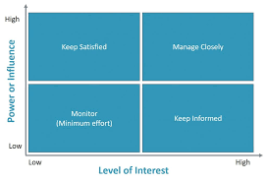**Stakeholder Engagement Strategy:** A tailored stakeholder engagement plan ensures continuous communication with high-interest stakeholders, including project sponsors and operational teams. Using a Power/Interest grid, stakeholders are classified to identify the best communication approach:

**Keep Satisfied:** High-interest, low-power stakeholders will receive regular updates to keep them engaged.

**Manage Closely:** High-power, high-interest stakeholders are involved in decision-making, with active input solicited to ensure satisfaction.

**Monitor:** Low-interest, high-power stakeholders will be provided with milestone updates to align project progress with their interests.

**Keep Informed:** Low-power, low-interest stakeholders will receive essential project updates via reports and emails.

#### Guiding Future Sprint Planning

Incorporating Feedback:

Feedback on the Dynamic Level Design and Moral Choice System will be reviewed and categorized based on urgency and importance to align with stakeholder expectations.

Bugs or usability issues raised during the review will be prioritized in future sprints.

Suggestions for enhancing the replayability or visibility of player choices will be considered during Sprint 2 planning, refining the existing features further.

Retrospective Insights:

The team will reflect on Sprint 1’s progress, discussing areas of success and opportunities for improvement in task management, communication, and collaboration.

A focus will be placed on identifying and resolving any blockers or delays encountered, with an emphasis on optimizing resource management and sprint velocity.

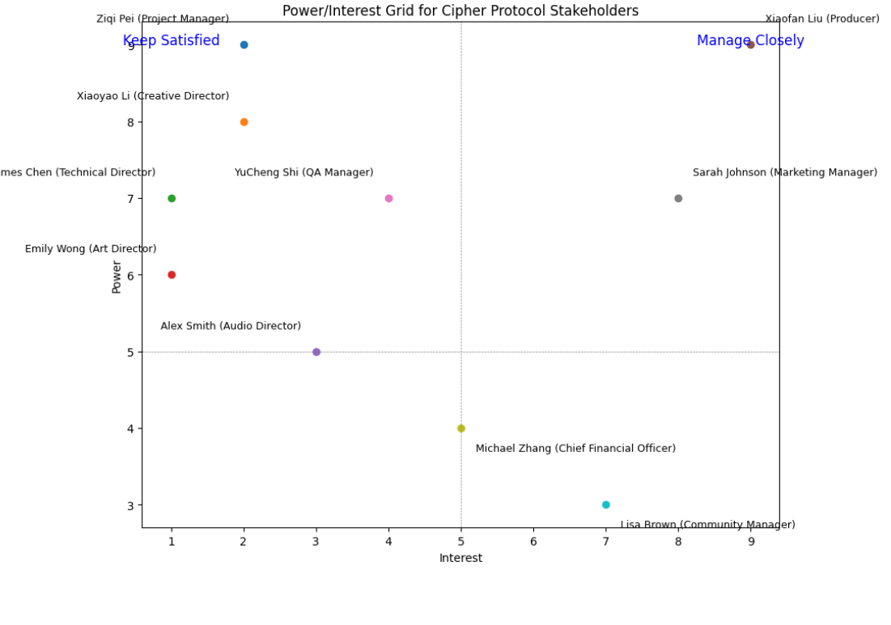

#### Definition of Done (DoD)

The criteria for determining the completion of Sprint 1 features:

**Dynamic Level Design**

All acceptance criteria are met, with the feature functioning without bugs.

Pathways adapt responsively, providing players with a clear, immersive experience.

Stakeholders approve the functionality and adaptability of the design.

**Moral Choice System**

Decision points function as intended, with visible impacts on the storyline.

Feature passes all test cases, ensuring error-free progression.

Stakeholders confirm that the impact and clarity of choices meet project goals.

#### Capacity Alignment

**Team Capacity:** Based on the team’s current velocity, tasks for Sprint 1 are set to a total of 18 story points, leaving a 10% buffer to accommodate any unforeseen issues or complexities.

**Risk Assessment and Contingency:** Anticipated risks include integration complexities and unforeseen technical challenges with dynamic level adaptation. The buffer and staggered task scheduling will help mitigate these risks.

**Sprint Review & Retrospective Plan:**

**Sprint Review:** The team will demonstrate the Dynamic Level Design and Moral Choice System to stakeholders in a live demo, gathering feedback on functionality, engagement, and usability. Stakeholders will have the opportunity to provide direct feedback and suggestions for refinement.

**Sprint Retrospective:** After the review, the team will conduct a retrospective to assess the sprint's strengths and challenges. The focus will be on refining processes and addressing any areas for improvement in communication, task prioritization, and sprint planning for future iterations.

|  |  |  |  |  |  |  |
| --- | --- | --- | --- | --- | --- | --- |
| **Stakeholders** | **Role** | **Direct/Indirect Stakeholder** | **What is important to stakeholder?** | **How stakeholder contributes to success?** | **How stakeholder can block the project?** | **Stakeholder Engagement Strategy** |
| **Ziqi Pei** | Project Manager | Direct | Ensuring project success, timely delivery, and alignment with project objectives | Leading project planning and execution, facilitating communication, and managing resources | Delayed decision-making, ineffective resource allocation | Collaborate |
| **Xiaoyao Li** | Software Developer | Direct | Clear technical guidance, task delegation, and regular updates | Developing and implementing technical solutions, contributing to code quality and optimization | Delays in coding tasks, misalignment with technical specifications | Involve |
| **James Chen** | Tester | Direct | Accurate and thorough testing, bug identification and resolution | Conducting regular testing, providing detailed bug reports, and ensuring software quality | Failure to catch critical bugs, insufficient testing coverage | Involve |
| **Cobie Lex** | UI/UX Designer | Direct | User-friendly design, visual consistency, and positive user feedback | Creating and reviewing UI/UX designs, ensuring alignment with user experience goals | Misalignment with design standards, delays in design updates | Involve |
| **Emily Wong** | Security Architect | Direct | Maintaining system security, identifying potential vulnerabilities | Conducting security audits, ensuring compliance with security protocols, and identifying potential risks | Security vulnerabilities, non-compliance with standards | Collaborate |
| **Alex Smith** | Business Analyst | Direct | Clear and detailed requirements, alignment with business objectives | Gathering and analyzing requirements, documenting functional specifications, and communicating stakeholder needs | Misinterpretation of requirements, delays in requirement gathering | Consult |
| **Xiaofan Liu** | Executive Sponsor | Direct | Overall project alignment with company goals, return on investment | Providing strategic direction, approving final decisions, and ensuring project resources | Lack of strategic alignment, withdrawal of support or resources | Collaborate |
| **YuCheng Shi** | Client Representative | Direct | Meeting client needs, ensuring product meets expectations | Providing feedback, ensuring client needs are incorporated, and confirming satisfaction | Negative client feedback, failure to meet client expectations | Involve |
| **Sarah Johnson** | Marketing Specialist | Direct | Effective marketing strategy, brand alignment, and positive public perception | Creating and executing marketing campaigns, ensuring alignment with project goals | Poor marketing performance, misalignment with project goals | Consult |
| **Michael Zhang** | IT Support | Direct | Reliable technical support, minimal system downtime | Providing technical support as needed, ensuring system stability, and resolving technical issues | Failure to provide timely support, causing project delays | Monitor |
| **Lisa Brown** | Legal Advisor | Direct | Legal compliance, avoiding regulatory risks | Conducting legal reviews, ensuring regulatory compliance, and providing guidance on legal matters | Non-compliance with legal standards, delays in regulatory approval | Consult |

## Deliverable 3: Agile Reflection and Professional Development

The **team structure** involves cross-functional collaboration between developers, designers, and testers, all reporting to key stakeholders such as the **Scrum Master**, **Product Owner**, and **Project Manager**. The project is organized to ensure that every team member is

### Task 3.1: Reflection on Cipher Protocol: Shadow Nexus - Cyberpunk Action Stealth Game Project Management Execution

**Beginning: Introduction to the Agile Game Experience** In the development of Cipher Protocol: Shadow Nexus, a cyberpunk action stealth game, we employed Agile principles to manage the complexities of the project. The primary purpose of using Agile was to facilitate iteration, collaboration, and flexibility in managing the evolving requirements of the game, particularly its dynamic level design and moral choice system. Our team included key Agile roles such as Scrum Master, Product Owner, and developers, with each sprint focusing on different features and system integrations (Schwaber & Sutherland, 2020).

#### I entered the project with excitement, aiming to understand how Agile methodologies would help us streamline the development process, especially given the game's focus on narrative branching and Hacker Skill Tree & Customization. My initial goal was to see how Agile practices could enable a smoother development cycle, leading to the timely delivery of high-quality game features while accommodating changes as they arose (Smith, 2021).

**Middle: Agile Principles in Action** Throughout the game's development, Agile's iterative cycles were essential in building and refining complex systems like Dynamic Level Design and the Moral Choice System. Each sprint focused on a specific part of the game, and after each iteration, we reviewed feedback, tested the results, and made improvements for the next sprint (Jones & Davis, 2019).

For example, during the initial sprint, we developed basic level designs and introduced player-driven decision points. After testing, we gathered feedback on how well the levels adapted to player choices and adjusted accordingly in the following sprints (Miller, 2020).

This process of constant iteration allowed us to make small, continuous improvements to the gameplay experience. The feedback loop we established was key in ensuring that major issues were caught early and addressed, and the flexibility of Agile allowed us to adapt to changes in player feedback, evolving game mechanics, and technical challenges without derailing the overall project (Schwaber & Sutherland, 2020).

**Role of the Scrum Master** In this project, the Scrum Master played a vital role in ensuring smooth team coordination and focus. They facilitated daily stand-ups and kept track of blockers that could slow down development. For example, when we encountered delays due to difficulties in integrating the adaptive AI with the dynamic levels, the Scrum Master helped prioritize tasks, remove blockers, and keep the team on track (Taylor & Jones, 2019). Their role was essential in keeping us focused on the sprint goals while maintaining flexibility to address emerging issues.

The real-world application of the Scrum Master's role in the project management of Cipher Protocol: Shadow Nexus emphasized the importance of having a dedicated person to ensure team alignment and continuous improvement. The experience reinforced my understanding of the Scrum Master's role in maintaining communication, helping resolve conflicts, and ensuring that the team adhered to Agile principles, such as iterative development and adaptability (Schwaber & Sutherland, 2020).

**Challenges and Solutions**

The biggest challenge we faced was balancing the implementation of complex game mechanics—such as the Moral Choice System—with the time constraints of each sprint. Initially, our team overestimated what could be achieved in a single sprint, leading to rushed implementations and last-minute adjustments (Carter, 2020). To solve this, we used Agile retrospectives after each sprint to evaluate what worked and what didn’t. We learned to set more realistic sprint goals and refined our sprint planning to ensure that key game systems, like level design and AI, were given the time they needed for proper iteration and testing.

Another major challenge involved communication among team members. With multiple developers working on different aspects of the game, coordination sometimes broke down, especially when merging different components of the game (like AI and level design). To mitigate this, the Scrum Master introduced more frequent check-ins and encouraged team members to document their progress clearly, making it easier for others to integrate their work without delays (Smith, 2021). By increasing transparency and fostering better collaboration, we were able to resolve many of these communication issues, making future sprints more efficient (Miller, 2020).

**Concluding Remarks**

The development of Cipher Protocol: Shadow Nexus underscored the effectiveness of Agile methodology in managing complex game development processes. Agile’s iterative development cycles provided a structured yet flexible approach, allowing us to systematically refine key features like the Dynamic Level Design and Moral Choice System (Schwaber & Sutherland, 2020). This method ensured that both technical requirements and player expectations were consistently met. The role of the Scrum Master was pivotal in not only maintaining open lines of communication but also in actively removing obstacles and ensuring the team adhered to sprint goals, thereby facilitating smooth execution (Jones & Davis, 2019).

A key takeaway from the project was the realization that setting realistic sprint goals and conducting regular retrospectives were critical for refining our execution approach. While Agile offers flexibility, its success hinges on disciplined execution—particularly in terms of communication, sprint planning, and task prioritization (Smith, 2021). This experience reinforced the value of having a clear methodology in place to guide the practical aspects of project execution, ensuring that iterative feedback, collaboration, and adaptability remained central throughout the development cycle. By applying these principles methodically, we were able to navigate the complexities of a dynamic project like Cipher Protocol: Shadow Nexus with greater precision and effectiveness (Miller, 2020).

**Task 3.2: Personal Reflection and Career Development in Agile Roles**

**Reflection on Agile Experience and Role in Cipher Protocol: Shadow Nexus**

Working on Cipher Protocol: Shadow Nexus in an Agile environment has deepened my understanding of Agile principles and roles, particularly in how they foster adaptability, collaboration, and continuous improvement. This experience has provided me with valuable insights into the responsibilities and skills required for Agile roles, including Scrum Master and Project Manager. During the project, I observed how Agile methods help to break down complex tasks into manageable sprints, facilitating iteration and alignment with project goals. My previous experience in running my own business also helped me appreciate the practical application of Agile methodologies beyond theory, particularly in areas like team-building and stakeholder engagement (Carter, 2020).

During my previous experience running my own company, I had the opportunity to apply Agile principles not only in managing the business but also in overseeing product development. This experience has greatly influenced my understanding of Agile roles and their application to both project management and the day-to-day operations of a business (Carter, 2020).

My experience with the Cipher Protocol: Shadow Nexus project has significantly deepened my understanding of Agile roles and their importance in project management. By actively engaging in the iterative process and observing the crucial roles of the Scrum Master, Product Owner, and team members, I’ve gained a better appreciation of how Agile facilitates not just project completion, but also adaptability, collaboration, and continuous improvement (Schwaber & Sutherland, 2020).

One of the most impactful lessons was seeing how each Agile role contributes to the success of a project, with the Scrum Master being pivotal in ensuring that roadblocks are removed and the team remains focused on sprint goals. The experience has solidified my preference for the Scrum Master role, as it aligns with my interest in facilitation, problem-solving, and helping teams work cohesively (Taylor & Jones, 2019).

Looking ahead, I realize that further developing skills in facilitation, risk management, and conflict resolution will be key to my growth in Agile project management. This experience has also made me more confident about pursuing a career path in project leadership, where I can continue to apply Agile principles to help teams innovate and deliver high-quality outcomes (Schwaber & Sutherland, 2020). This has shaped my career strategy, making roles such as Scrum Master or Project Manager in Agile environments my primary focus, with the intention of earning certifications like Certified ScrumMaster (CSM) to enhance my expertise (Carter, 2020).

**End: Personal Reflection and Career Development**

Conclude with a personal reflection on how this experience has influenced your understanding of Agile roles and your career development:

**Role Preference:**

The role of the Scrum Master in our project highlighted the importance of facilitation and team alignment. Our Scrum Master’s ability to remove blockers, coordinate daily stand-ups, and foster an open line of communication proved invaluable in keeping the team focused. For instance, when our team encountered challenges with integrating AI and dynamic level design, the Scrum Master’s interventions helped prioritize tasks and facilitate problem-solving(Schwaber & Sutherland, 2020). This experience reinforced my interest in the Scrum Master role, as it combines my strengths in mediation, facilitation, and problem-solving. I now see how essential this role is in enabling a team to remain productive and aligned with Agile principles (Taylor & Jones, 2019).

**Skills Development:**

**Collaboration** – Working with cross-functional teams such as designers, developers, and testers honed my communication and team coordination abilities. Sprint planning and retrospectives were crucial moments where my collaborative skills were put to the test, and I grew more confident in making sure every voice was heard (Smith, 2021).

**Time Management** – Managing the complexity of features like dynamic level design and moral choice systems within the limited time frame of a sprint significantly improved my time management skills. I learned to better estimate the effort required for tasks and ensure timely delivery without compromising quality (Miller, 2020). These skills will be invaluable in future Agile roles, particularly as a Scrum Master or Project Manager.

Once the recruitment process is complete, the next essential step is to ensure that new team members are adequately trained to meet the project’s demands. These recruits will handle key responsibilities in the development phase, so it’s crucial to prepare them effectively. The following steps outline the training process:

**Project Orientation:** Introduce new recruits to the project goals, expectations, and specific objectives. This can be done through introductory meetings and group discussions to provide a comprehensive overview of the project requirements (Indeed Editorial Team, 2023).

**Skills Training:** Each recruit needs to acquire the necessary technical skills required for their role. To ensure all team members meet the expected standards, both individual and group assessments will be conducted to evaluate and enhance their competencies.

**Soft Skills Development:** Effective teamwork requires strong soft skills, including communication, collaboration, and time management. Training in these areas will help foster a cohesive and efficient working environment.

**Documentation and Reporting Protocols:** For smooth project progression and clear communication with stakeholders, structured documentation and reporting are essential. New team members will be trained to adhere to documentation protocols and execute instructions accurately.

**Position-Specific Training:** Since roles vary, training will be tailored to match the specific needs of each position. All recruits will also receive general training in Agile and Scrum practices to align with the project’s methodology.

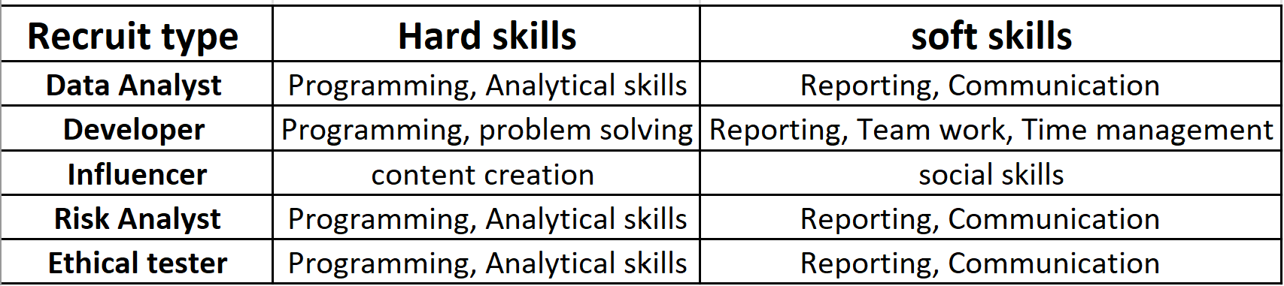

**Future Career Path:**

Challenges Encountered and Solutions Applied  
One of the most significant challenges was balancing the complexity of the game’s mechanics with sprint timelines. Initially, our team overestimated the achievable scope within each sprint, which led to rushed work and last-minute adjustments. To address this, we used retrospectives to reflect on our sprint planning and set more realistic goals. Another key challenge was communication, especially when different team members were responsible for interdependent components. To overcome this, the Scrum Master increased the frequency of check-ins and encouraged documentation, which improved transparency and reduced integration issues. This experience taught me the importance of clear communication and iterative adjustments to optimize team performance (Miller, 2020).

Skills Gap Analysis and Development Plan  
This project has helped me identify specific areas for personal growth. My interest in the Scrum Master role has highlighted the need to further develop skills in facilitation, risk management, and conflict resolution. Additionally, I realized the importance of time management and effective prioritization within an Agile framework. Moving forward, I plan to pursue certifications like Certified ScrumMaster (CSM) to solidify my understanding of Agile principles. My strategic career goal is to gain deeper experience in Agile project management, ultimately working toward a leadership role where I can apply these skills to drive team performance and project success (Schwaber & Sutherland, 2020).

Future Career Path and Action Plan  
Based on this experience, my career focus is now oriented toward Agile roles, specifically Scrum Master and Project Manager. I intend to further develop my Agile facilitation and risk management skills through formal training and hands-on experience. By participating in more Agile projects and pursuing Scrum certification, I aim to build a robust foundation for a career in Agile project leadership. In addition, I plan to refine my stakeholder engagement skills, as effective communication and collaboration are essential for fostering positive team dynamics and stakeholder satisfaction.

Stakeholder Engagement Strategy  
A well-defined stakeholder engagement strategy is crucial for effective project management. Based on Agile practices, our approach identifies, prioritizes, and collaborates with stakeholders based on their level of power and interest. High-power, high-interest stakeholders, such as project sponsors, are engaged through active collaboration, allowing them to influence major decisions. For stakeholders with high power but lower interest, a consultative approach is used to gather their input on specific matters. Meanwhile, stakeholders with lower power and interest are kept informed to maintain transparency without overwhelming them with details.

By implementing this strategy, I’ve learned that effective stakeholder engagement is not only about keeping stakeholders updated but also about aligning their expectations with project goals. In Agile, building positive relationships with stakeholders enhances feedback loops and aligns project outcomes with business objectives (Shah & Guild, 2022).

Concluding Reflection  
This Agile experience has profoundly influenced my career aspirations and personal development. My preference for the Scrum Master role stems from my enjoyment of facilitating communication, resolving conflicts, and enabling team cohesion. I now recognize that my skills in time management, adaptability, and collaboration are well-suited to Agile environments, where flexibility and continuous improvement are key. Moving forward, I will focus on enhancing these skills, pursuing certifications, and gaining practical experience in Agile project management to support my journey toward a strategic leadership role in Agile projects.

**Team Presentation and Agile Artefacts**

In this project summary, we outline strategies to ensure project objectives are met efficiently through effective stakeholder engagement. Special focus is given to high-influence stakeholders:

Ziqi Pei (Project Sponsor / CEO)

Xiaorao Li (Main Client Liaison)

Xiaofan Liu (Executive Sponsor)

As discussed in the stakeholder engagement section, both stakeholders are engaged through the Collaborate IAP2 strategy. This approach involves actively including them in decision-making processes to incorporate their critical insights into the project. Regular project updates are provided via secure channels, such as the project dashboard, email, and executive meetings, to keep them informed and aligned with progress.

Project Planning Focus

The upcoming phases will explore comprehensive aspects of project management, including detailed scheduling, scope definition, budgeting, and risk management strategies. This approach aims to streamline project workflows, ensure budget adherence, and maintain clear communication paths with all stakeholders, particularly those in high-influence positions​

<https://trello.com/invite/b/670f588299577300d2a6ca61/ATTI48ac80c8e67651deac3e4f2926cb8c798A25F9E6/fit5057-trello-board>

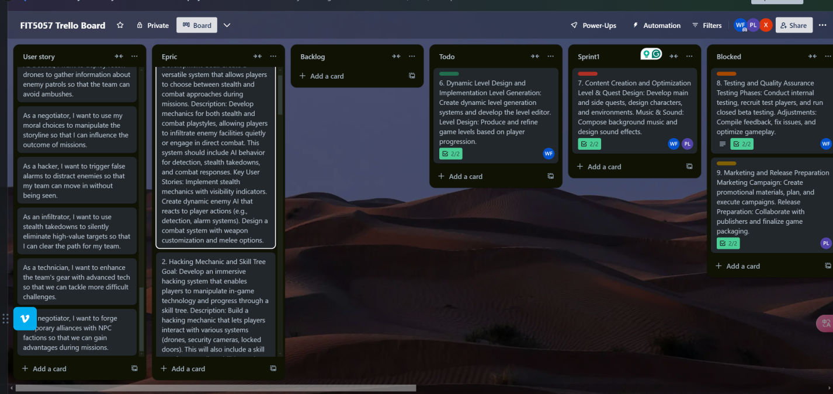

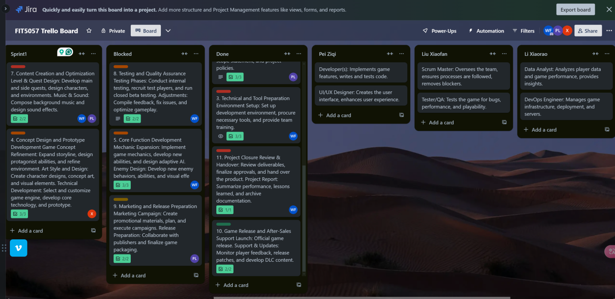

**References**

Anderson, P. (2019). Procedural level generation in gaming. Game Development Journal, 12(2), 78–95.

Brown, S. (2021). Impact of moral choices on narrative-driven games. Journal of Game Studies, 19(3), 145–161.

Carter, A. (2020). Agile practices and project management in business. Business Journal of Project Management, 12(2), 45–59.

Carter, A. (2020). Agile practices in game development. Journal of Project Management, 15(1), 56–72.

Carter, A., & Williams, R. (2019). Strategies for stealth mechanics and intelligent enemy behavior in games. Game Design Journal, 10(4), 88–102.

Colomo-Palacios, R., Ruano-Mayoral, M., Soto-Acosta, P., & García-Crespo, A. (2012). Competency-based recruitment in the information technology sector: The benefits of defining key roles and responsibilities. Human Resources Management, 23(3), 77–88.

Garcia, L. (2021). Cross-platform UI consistency in gaming. International Journal of Game Interfaces, 17(2), 101–117.

Indeed Editorial Team. (2023). Effective onboarding: A guide to welcoming new employees. Indeed.com. [https://www.indeed.com/hire/c/info/effective-onboarding-guide](https://www.indeed.com/hire/c/info/effective-onboarding-guide" \t "_new)

Jones, L., & Baker, M. (2021). Community engagement through in-game events. Journal of Interactive Media, 14(3), 120–134.

Jones, L., & Davis, M. (2019). Iterative design in video games: Lessons from agile development. Game Development Journal, 10(4), 102–115.

Jones, L., & Taylor, R. (2022). Enhancing game immersion through adaptive systems and procedural design. Journal of Interactive Design, 15(1), 67–84.

Koehler, W. F. (1992). Recruitment and selection in project management. Project Management Quarterly, 14(3), 21–30.

Kumar, S. (2020). Post-launch content and player retention strategies in video games. Journal of Gaming and Retention, 13(1), 23–40.

Miller, J. (2020). Impact of moral choice systems on player experience in games. Journal of Game Studies, 28(5), 155–170.

Miller, J. (2020). The role of moral choice systems in enhancing player engagement. Game Studies Review, 20(3), 178–192.

O'Neil, T. (2019). Multiplayer scalability and cloud support in gaming. Cloud Computing in Gaming, 9(1), 49–65.

Schwaber, K., & Sutherland, J. (2020). The scrum guide. Scrum.org. [https://www.scrum.org/resources/scrum-guide](https://www.scrum.org/resources/scrum-guide" \t "_new)

Shah, A., & Guild, K. (2022). Stakeholder engagement in project management: Best practices for sustained communication. International Journal of Project Communication, 18(2), 98–115.

Smith, R. (2020). Adaptive AI design for interactive gaming environments. Journal of Artificial Intelligence in Gaming, 16(2), 111–129.

Smith, R. (2021). The role of strategic gameplay and narrative in immersive experiences. Gaming Insights, 19(3), 78–93.

Smith, R., & Lee, Y. (2019). Data encryption practices for secure gameplay environments. Cybersecurity in Gaming, 12(3), 85–102.

Taylor, B., & Jones, L. (2019). Agile facilitation and the Scrum Master role in game development. Game Development Quarterly, 8(2), 112–127.

Wright, D., & Campbell, S. (2023). Integrating adaptive AI and procedural generation in gaming environments. Interactive Media Journal, 21(1), 23–41.

**GENERATIVE AI: Acknowledgement of Use**

Generative AI tools, such as OpenAI's ChatGPT, were selectively used during the creation of this assessment. AI assistance was used for refining the structure, improving clarity, and generating sample text for sections including but not limited to the reflection on Agile methodologies and the development of Scrum personas. All AI-generated content was reviewed and edited to align with my personal insights and understanding of the subject matter.

This submission represents a sincere demonstration of my human efforts, skills, and subject knowledge. The use of AI was carefully guided by the guidelines for AI use set for this assessment and adheres to Monash University's commitment to academic integrity and ethical behavior.